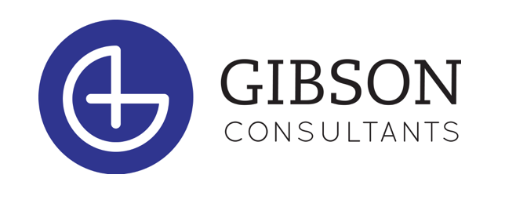

POSITION: Executive Search Research Associate

Company Overview

Gibson Consultants (www.gibson-consultants.com) is a Wilmington-based executive search firm. We are sometimes called recruiters or headhunters. CEO often say, “Our people are our greatest asset.” Building upon that idea, our mission is to help our client companies build strong leadership teams.

Since 2002, we have built a successful business focusing on healthcare companies. Healthcare is one of the largest and most dynamic sectors in the US. It’s roughly 1/6th of the US economy and has been undergoing massive change, which has made talent that much more valuable.

We are enjoying greater demand for our services than ever before. This has allowed us to build an entrepreneurial company with a fun-loving culture. For example, every quarter we engage in philanthropy events together and host social events.

We are small enough to be nimble and fun, yet large enough to be financially stable, with a good reputation in our market. With a start-up feel, we’re experienced enough to have invested well in technology platforms and systems, and we provide lots of support to our Search Consultants.

Our office works collaboratively, helping each other succeed, and our work environment is free of bureaucracy and office politics. Our people work here because they want to be here.

The Opportunity

Gibson Consultants is looking for a motivated UNCW student who is thinking about a career in recruiting or sales after graduation.
- Our internship provides a unique opportunity to get involved with an executive search firm and learn about the business while helping our current recruiters and office staff.
- The intern position includes a variety of responsibilities including special projects, research, database maintenance
- Potential interns should possess the following:
  - Self-motivation
  - Resourcefulness
  - Good time management skills
  - Proficiency in Microsoft Word and Excel
  - Basic knowledge of LinkedIn is desirable
- Interns should be able to commit to 10 - 15 hours per week during the school year and 30 - 35 hours per week during the summer. The internship is located at our HQ in Wilmington.

Gibson’s Goal

Our internship was created to enhance the educational experience of students through hands-on work.

We hope to give you a valuable look into what a career as an Executive Search Consultant would look like with Gibson Consultants post-graduation. Our interns are encouraged to learn and join in the process because we want you to apply to join us full-time following the internship.

Who Succeeds at Being a Recruiter?

It’s easy to predict those that will succeed in this business. They are:

- smart
- relentless
- confident
- goal-oriented
- entrepreneurial

They are quick learners who enjoy talking to people and building relationships. They also have:

- drive
- passion
- energy
- an outgoing, fearless personality
- communication skills

What We Want

If you are looking for an internship that has real career potential and you have the qualities above, this may be the right opportunity for you. Particularly if you:

- believe in yourself
- are entrepreneurial and driven to succeed
- know what it means to work hard toward goals
- expect to be rewarded, financially and professionally, for meeting and exceeding those goals
- want to invest in yourself and your career, delaying short-term gratification for a career and income that will surprise you…but also like the idea of doing something meaningful

Next Steps

Please submit your application, resume, and cover letter to:
employment@gibson-consultants.com

*If you do not have the application, please just send your resume and cover letter to the above address. We will follow up with a copy of our application upon receipt.

Gibson Consultants is proud to be an equal opportunity employer and is dedicated to pursuing and maintaining an inclusive and diverse workplace.

