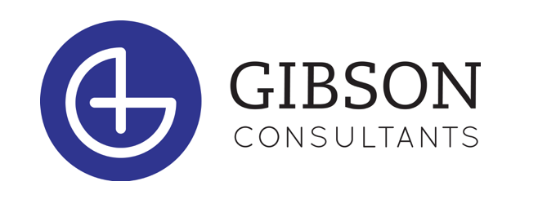

POSITION: Executive Search Consultant
(Candidate Recruiter)

Company Overview: Who We Are and Why Us

Gibson Consultants (www.gibson-consultants.com) is a Wilmington-based executive search firm. We are sometimes called recruiters or headhunters. CEOs often say, “Our people are our greatest asset.” Building upon that idea, our mission is to help our client companies build strong leadership teams.

Since 2002, Gibson Consultants has built a successful business focusing on healthcare companies. Healthcare is one of the largest and most dynamic sectors in the US. It’s roughly 1/6th of the US economy and has been undergoing massive change, which has made talent that much more valuable.

We are enjoying greater demand for our services than ever before. This has allowed us to build an entrepreneurial company with a fun-loving culture in our Wilmington headquarters. For example, every quarter we engage in philanthropy events together and host social events.

We are small enough to be nimble and fun, yet large enough to be financially stable, with a good reputation in our market. With a start-up feel, we’re experienced enough to have invested well in technology platforms and systems, and we provide lots of support to our Search Consultants.

Our office works collaboratively, helping each other succeed, and our work environment is free of bureaucracy and office politics. Our people work here because they want to be here.

The Opportunity: Benefits of Joining Our Team

Consider these benefits of joining our team:
- Comprehensive training program including foundational recruiter skills, healthcare industry knowledge, tools and technology, office systems
- Ongoing training and development, and opportunities for continuous education
- Work within a team in a defined practice area
- Growth potential within the organization including a career path within recruiting, or into business development
- Unlimited earning potential, including a competitive base salary and uncapped commission structure
- Work in a dynamic and competitive work environment that doesn’t sacrifice teamwork and support

Responsibilities
As a Recruiter you will impact both our candidates and customers by finding the right people for the right jobs. You will…
- Identify qualified candidates through various recruiting and sourcing tools
- Screen and interview qualified candidates
- Partner with your Client Manager to identify top accounts, target skill sets, and key market segments
- Build and maintain relationships with industry contacts to gain knowledge and generate referrals and sales leads
- Perform various customer service related activities
- Give back to your community by volunteering and partnering with various philanthropic organizations

Qualifications
- Bachelor’s or Associates degree OR military experience OR at least 2-4 years of professional experience in the healthcare industry
- Desired skills
  - Excellent written and oral communication
  - Effective time management
  - Basic knowledge of LinkedIn
- Desired attributes
  - Self-motivated
  - Desire to learn
  - Resourceful
  - Sense of urgency
  - High standard of professionalism and character
  - The ability to persevere in entrepreneurial and high-pressure situations
- Ability to work in-person at the office and remotely (hybrid work environment). Position is located at our HQ in Wilmington.

Benefits
- We provide a competitive base salary, commission, and an exceptional benefits package including:
  - A generous vacation schedule and office holidays
  - Employee benefits: medical (premium cost share), dental, prescription, vision, life & accident insurance, short & long-term disability coverage, and a life-balance referral and counseling service program!
  - SIMPLE IRA company-matched retirement savings plan
- A hybrid work environment

Next Steps

Please submit your application, resume, and cover letter to:
employment@gibson-consultants.com

*If you do not have the application, please just send your resume and cover letter to the above address. We will follow up with a copy of our application upon receipt.

Check out the Prospective Employee page on our website

Gibson Consultants is proud to be an equal opportunity employer and is dedicated to pursuing and maintaining an inclusive and diverse workplace.

