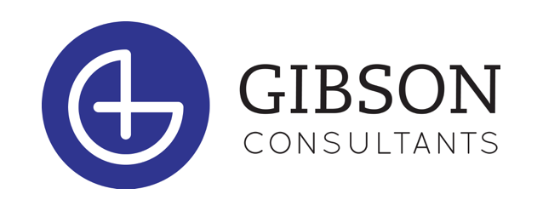

POSITION: Executive Search Research Associate (Intern)

Company Overview: Who We Are and Why Us

Gibson Consultants (www.gibson-consultants.com) is a Wilmington-based executive search firm. We are sometimes called recruiters or headhunters. CEOs often say, “Our people are our greatest asset.” Building upon that idea, our mission is to help our client companies build strong leadership teams.

Since 2002, Gibson Consultants has built a successful business focusing on healthcare companies. Healthcare is one of the largest and most dynamic sectors in the US. It’s roughly 1/6th of the US economy and has been undergoing massive change, which has made talent that much more valuable.

We are enjoying greater demand for our services than ever before. This has allowed us to build an entrepreneurial company with a fun-loving culture in our Wilmington headquarters. For example, every quarter we engage in philanthropy events together and host social events.

We are small enough to be nimble and fun, yet large enough to be financially stable, with a good reputation in our market. With a start-up feel, we’re experienced enough to have invested well in technology platforms and systems, and we provide lots of support to our Search Consultants.

Our office works collaboratively, helping each other succeed, and our work environment is free of bureaucracy and office politics. Our people work here because they want to be here.

Our internship was created to enhance the educational experience of students through hands-on work.

The Opportunity: Benefits of Joining Our Team as an Intern

If you are a motivated student who is thinking about a career in recruiting or sales after graduation, consider these benefits of joining our team:
- Growth potential within the organization including the opportunity for a career path towards joining the company as an Executive Search Consultant/recruiter after graduation (we currently have 4 former interns who were hired after graduation as full time employees)
- Extensive training on commonly used technology platforms (Salesforce, LI recruiter etc.)
- Learning about the healthcare industry from a team that focuses solely on the business of healthcare
- Involvement in various aspects of recruiting, including observing the day-to-day responsibilities and opportunities of Executive Search Consultants
- Participation in company culture initiatives including philanthropic and social events
- Being part of a company that fosters teamwork and support for each other

We hope to give you a valuable look into what a career as an Executive Search Consultant would look like with Gibson Consultants post graduation. Our interns are encouraged to learn and join in the process because we want you to apply to join us full-time following the internship.

If you are wondering what a career in recruiting might look like at Gibson Consultants, click here for the position description of an Executive Search Consultant at our firm

Responsibilities
Our Interns report to the Manager of Learning & Development and are a part of the Support Team. Intern learning and projects assist our recruiters and management through a mix of project-based and task-oriented activities.

Examples of typical Intern assignments include:
- Special projects that assist management such as researching benefits of new technology tools
- Assistance with company marketing projects as needed (may include social media or other communications)
- Research including helping recruiters identify relevant people and their contact information
- Database management including adding information into the database, and assisting with database cleanup and integrity
- Participation in planning for culture initiatives such as philanthropic and social events

Qualifications
- Currently enrolled in a degree program at an accredited college or university
- Desired skills
  - Good written and oral communication
  - Effective time management
  - Basic knowledge of LinkedIn
- Desired attributes
  - Self-motivated
  - Desire to learn
  - Resourceful
- Interns should be able to commit to 10 - 15 hours per week during the school year and 30 - 35 hours per week during the summer. The internship is located at our HQ in Wilmington and is a mix of in-person and remote work environment.

Benefits
- Interns are hourly employees. You will fill out a time sheet and receive compensation at an hourly rate for the hours worked

Next Steps

Please submit your application, resume, and cover letter to:
employment@gibson-consultants.com

*If you do not have the application, please just send your resume and cover letter to the above address. We will follow up with a copy of our application upon receipt.

Check out the Prospective Employee page on our website

Gibson Consultants is proud to be an equal opportunity employer and is dedicated to pursuing and maintaining an inclusive and diverse workplace.

